**Syed Haziq Hussain (24K-0944)**

**Lab # 02**

**Lab Tasks:**

**Q1: ALGORITHM:**

1. Greet user with “ Welcome, How may I help you? “.
2. Show user the **MENU**
3. Read **Order**
4. Calculate **BILL**
5. Take add on from the user
6. Set **BILL** TO **BILL + Add on**
7. Display user the BILL
8. Get **Payment**
9. Display **Waiting Time**

**PSEUDOCODE:**

START

PRINT “**Welcome, How may I help you**”

PRINT **Menu**

Input **Order**

PRINT “**Do you want any add ons. Yes or n**o? “

PRINT **Add_ons**

IF **Add_ons** == “Yes”

THEN

CALCULATE **TotalBIll = Bill + Add_On_Bill**

ELSE

CALCULATE **TotalBill = Bill**

PRINT “Here is your Bill”, **Bill**

Input **Payment**

PRINT **Display_Time**

END

**FLOWCHART:**

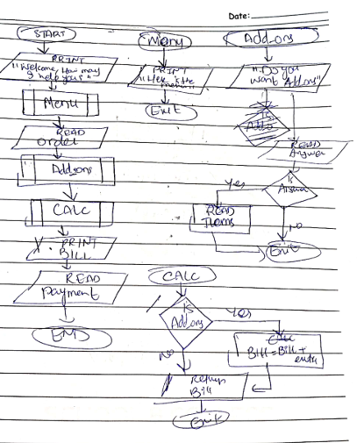

**Q2.**

**ALGORITHM:**

1. Prompt the user with “Enter your account number”
2. Read the Account_number
3. Check if Account_number is Valid
4. IF it is invalid
5. Prompt user with “Invalid Account number”
6. Else ask user “Enter the deposit amount”
7. Read Deposit_Amount
8. IF Deposit_Amount is greater than zero
9. Return the appropriate amount
10. Else ask the user to enter the amount again.

**PSERUDOCODE:**

START

Print “Enter the account number”

Input Account_Number

IF NOT is_valid(Account_Number) THEN

PRINT “Invalid Account”

EndIF

Print “Enter the deposit amount”

Input Dep_Amount

IF Dep_Amount <= 0 THEN

PRINT “Invalid amount”

EndIF

SET Balance TO GetBalance(Account_Number)

SET NewBal TO Balance + Dep_Amount

Set_acc_balance(Account_Number, NewBal)

PRINT “Deposit Successful”

END

**FLOWCHART**

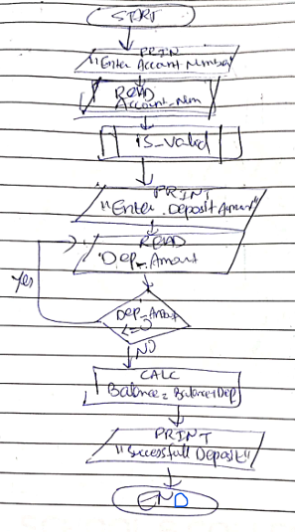

**Q3:**

**ALGORITHM:**

1. Ask the user to enter three different numbers
2. Read all the numbers
3. SET LARGE to first number
4. Check if the second number is greater than first and the third number
5. IF it is
6. SET LARGE to second number
7. Check if the third number is greater than the first two numbers
8. IF it is
9. SET LARGE to Third number
10. PROMPT User with a message to tell them the largest number

**PSEUDOCODE:**

START

PRINT “Enter three random numbers”

Input N1, N2, N3

SET Large = N1

IF N2 > N1 AND N2 > N3 THEN

SET Large = N2

ELSEIF N3 > N2 AND N3 > N1 THEN

SET Large = N3

ENDIF

PRINT “The largest of the three numbers is”, Large

END

FLOWCHART   
  
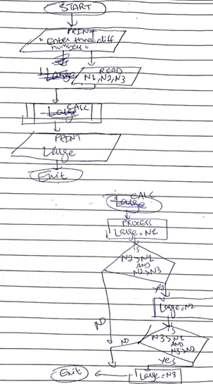  
  
  
  
  
  
  
  
  
  
  
  
  
  
  
  
  
  
  
  
  
  
**Q4.**

**PSEUDOCODE / ALGORITHM:**

START

PRINT “Enter a number between 1 and 12 inclusive”

Input Num

IF Num <1 OR Num > 12 THEN PRINT “Invalid Month

If Num == 1 THEN PRINT “JANUARY”

If Num == 2 THEN PRINT “FEBURARY”

If Num == 3 THEN PRINT “MARCH”

If Num == 4 THEN PRINT “APRIL”

If Num == 5 THEN PRINT “MAY”

If Num == 6 THEN PRINT “JUNE”

If Num == 7 THEN PRINT “JULY”

If Num == 8 THEN PRINT “AUGUST”

If Num == 9 THEN PRINT “SEPTEMBER”

If Num == 10 THEN PRINT “OCTOBER”

If Num == 11 THEN PRINT “NOVEMBER”

If Num == 12 THEN PRINT “DECEMBER”

END

**Q5.**

START

Print “Enter a number, an operator(+ or -), and another number. In that order”

Input N1, operator, N2

IF operator == “+” THEN

Result = N1 + N2

ELSE

Result = N1 – N2

Print Result

END

**Q5.**

**FLOWCHART:**

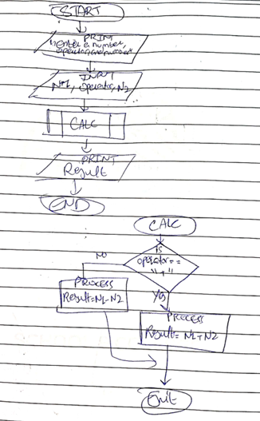

**Q6.**

**ALGORITHM:**

1. Ask the user 2 numbers and an operator (+, -, *, / )
2. Read the numbers and operator in different variables
3. Check what the operator is
4. IF it is “+” THEN
5. SET Result To Num1 + Num2
6. IF it is “-“ THEN
7. SET Result To Num1 – Num2
8. IF it is “*” THEN
9. SET Result TO Num1 * Num 2
10. Else, SET Result To Num1 / Num2
11. Display Result

**Q7**

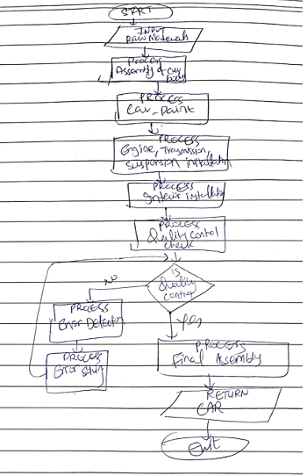

**Q8.**

<https://github.com/haziq325/Haziq_24k-0944>

**Q9.** Why we use .gitignore?

**.**gitignore file is used in a git repository to ignore the files and directories which are unnecessary to project this will be ignored by the git once the changes as been committed to the Remote repository. The type of files which will gets ignored are the mainly temporary files and the files which should not be versioned.

**Q10.** Difference between Algorithm and Pseudocode?

|  |  |
| --- | --- |
| **ALGORITHM** | **PSEUDOCODE** |
| A sequence of steps to solve a given problem is called as algorithm. Thus, an algorithm is a step-by-step procedure developed for solving a given problem. An algorithm consists of sequences, iterations, selections, etc. The selection of an algorithm depends upon the nature of the given problem. Thus, the problem is first analyzed, and then the best algorithm is used to solve it.  An algorithm follows a systematic and a logical approach, where the procedure is defined step-wise. In an algorithm, many simple operations are combined to help form a more complicated operation, which is performed with ease by the computer | Pseudocode is an informal method of developing an algorithm. Thus, computer programmers use simple informal language to write a pseudocode. It does not have any specific syntax to follow. The pseudocode is text-based design tool. Basically, pseudocode represents an algorithm to solve a problem in natural language and mathematical notations.  Pseudocodes are written in plain English, and they use short phrases to represent the functionalities that the specific lines of code would do. |